Wang Zhang

CSC 5560  Dr. Lee

LAb 3 report

1.

Base on Lab 2, I added a google search service to lab 3

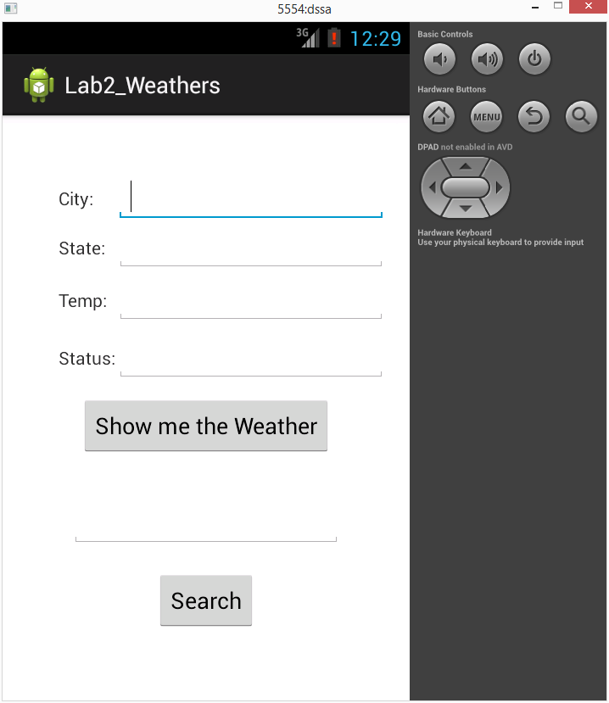

This is initial screenshot. As show above, it contain two part. One upper part is display weather of Kansas City. Another part is google search function. Put whatever information on text field and then click Search bottom. The browser will display information whatever you search for.

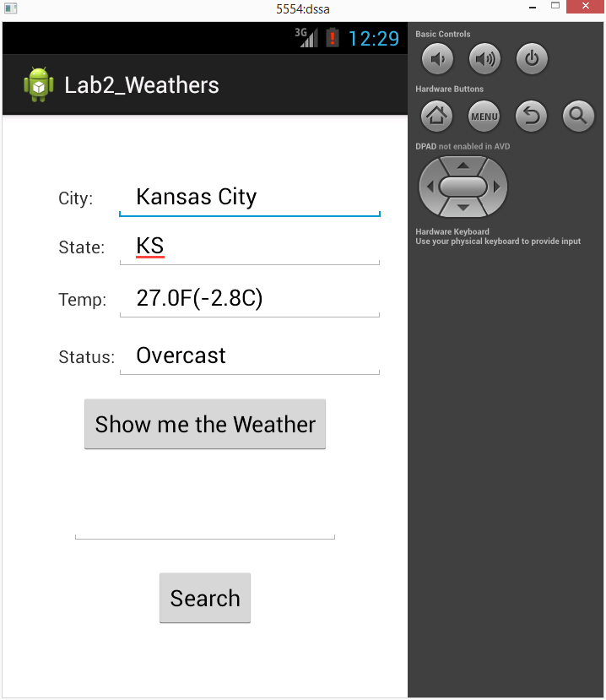

After click “Show me the Weather” bottom, the Kansas City will display on text fields.

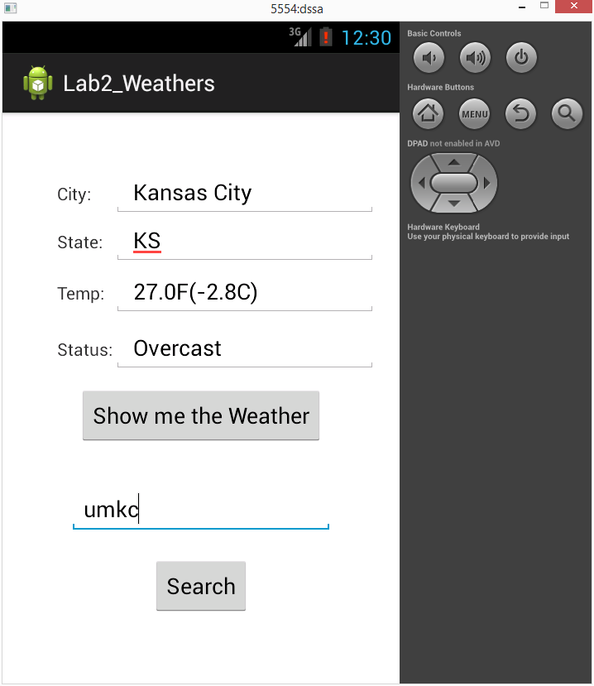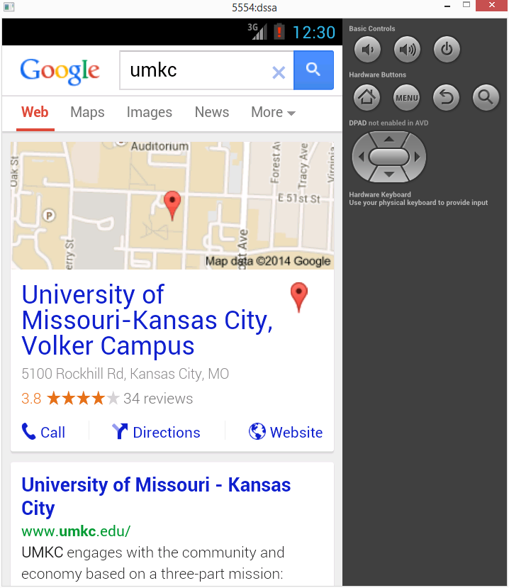

After I put UMKC on text field and click Search bottom, the browser will open and display the information about UMKC.

2.

Cloudera/MapReduce: Download the Cloudera Image, implement the WordCount MapReduce and run it. 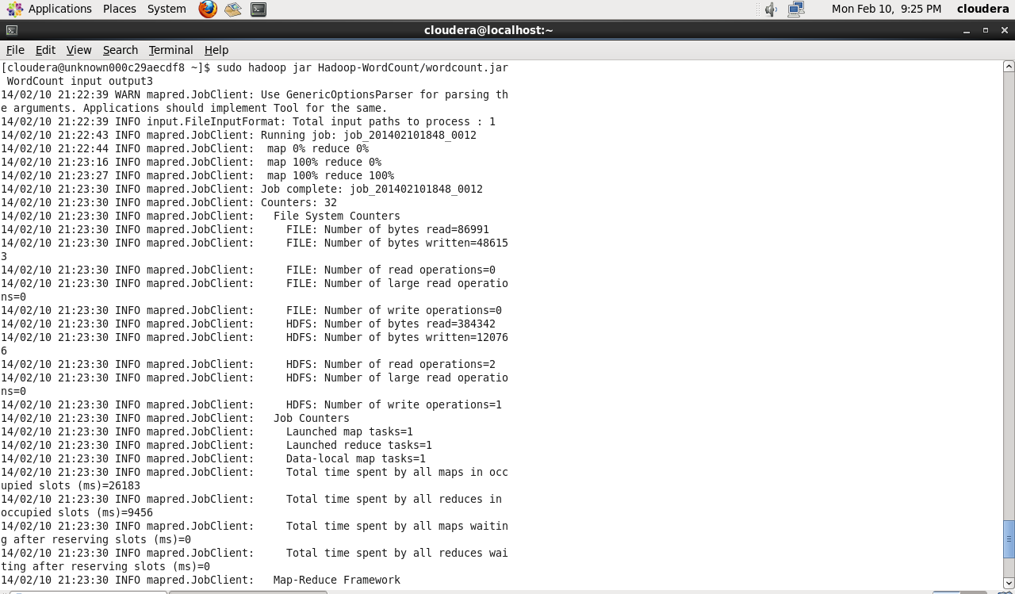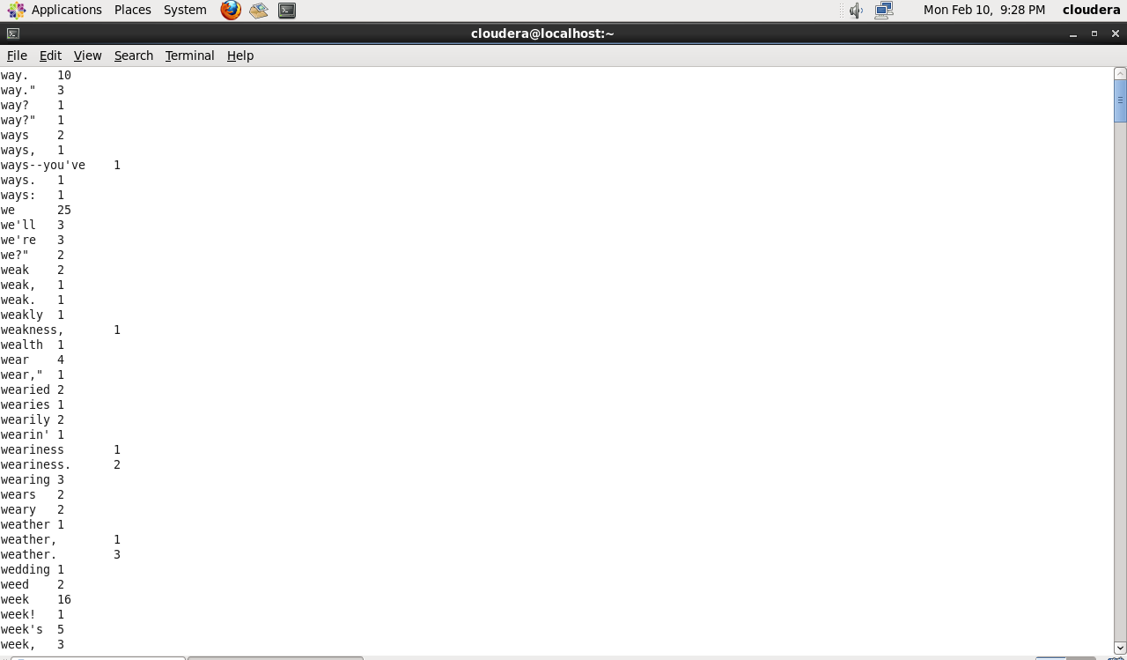

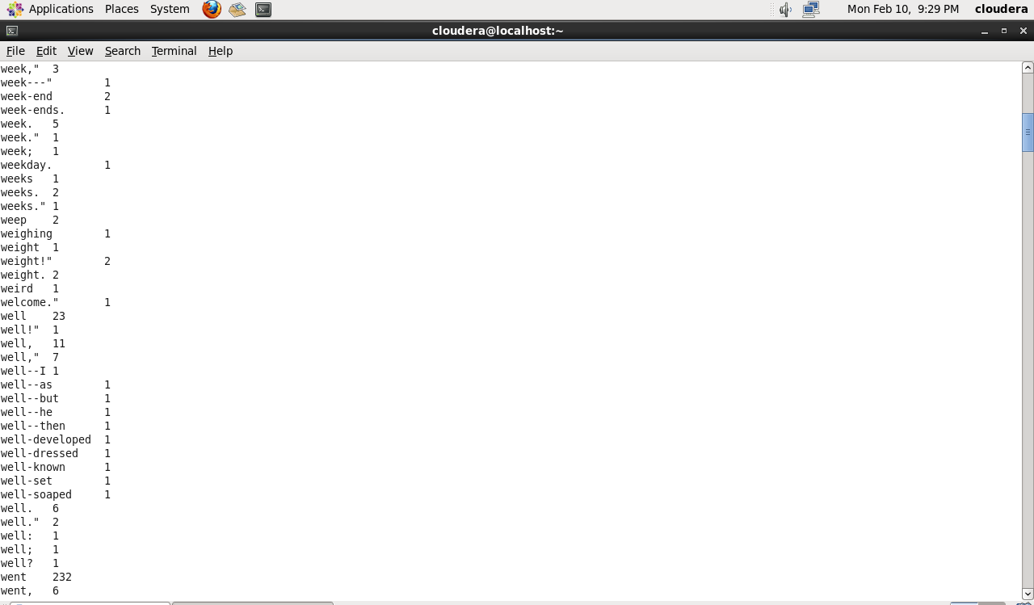

3.

Cloudera/Mahout: Configure your Cloudera with Mahout. Run Naive Bayes classifier with the input data

